*/\* 1 \*/*

DATA anova;

INPUT brand $ weartime @@;

DATALINES;

A 8 A 10 A 9 A 11 A 10 A 10 A 8 A 12

N 4 N 7 N 5 N 5 N 6 N 7 N 6 N 4

T 12 T 8 T 10 T 10 T 11 T 9 T 9 T 12

;

PROC ANOVA DATA=anova;

CLASS brand;

MODEL weartime=brand;

MEANS brand/SNK;

RUN;

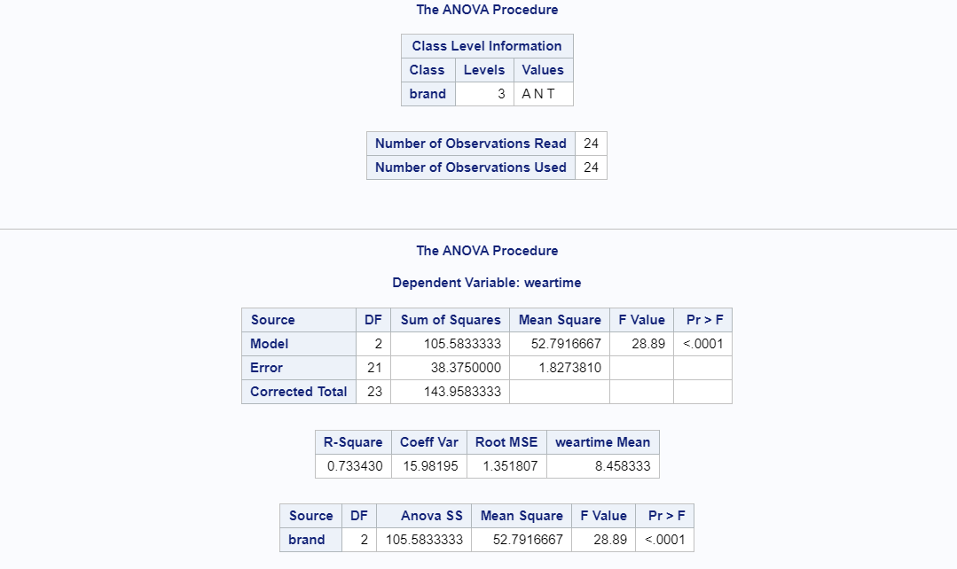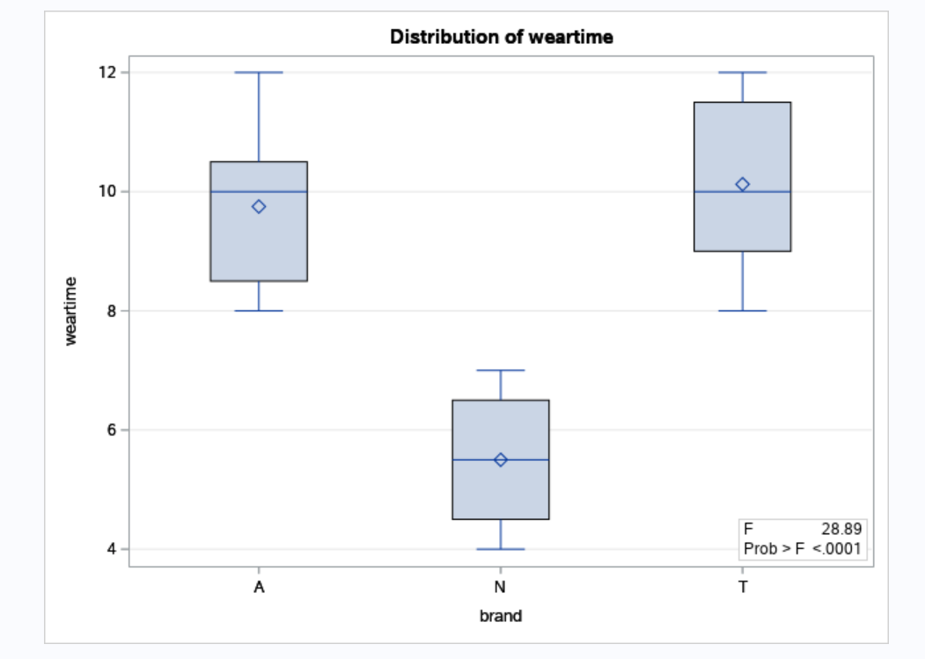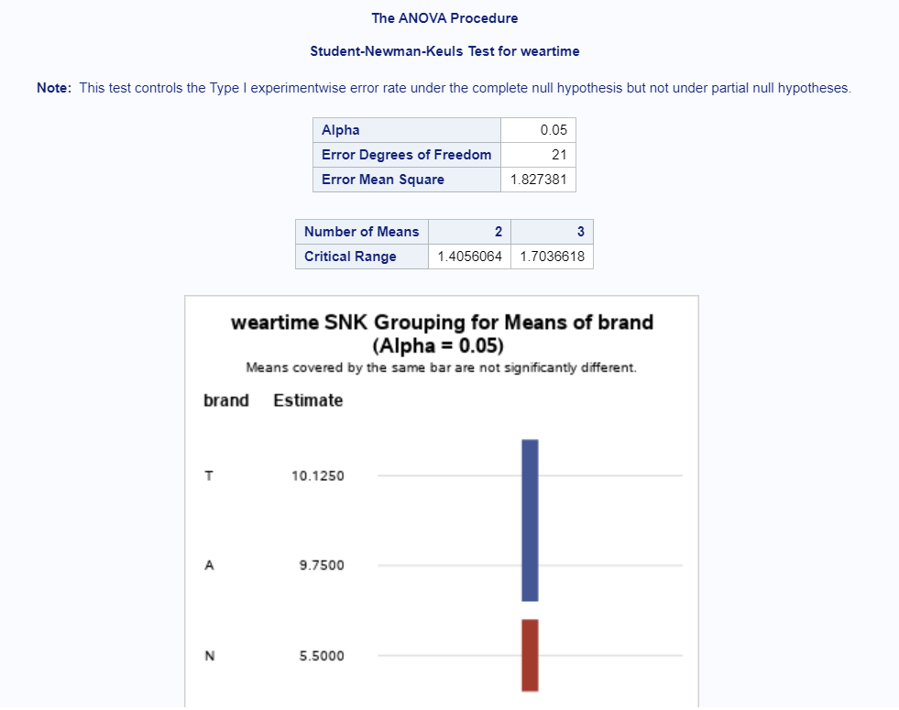

*/\* 2 \*/*

DATA cholesterol;

INPUT treat $ values @@;

DATALINES;

A 220 A 190 A 180 A 185 A 210 A 170 A 178 A 200 A 177 A 189

B 160 B 168 B 178 B 200 B 172 B 155 B 159 B 167 B 185 B 199

P 240 P 220 P 246 P 244 P 198 P 238 P 277 P 255 P 190 P 188

;

PROC ANOVA DATA=cholesterol;

CLASS treat;

MODEL values=treat;

MEANS treat/tukey;

RUN;

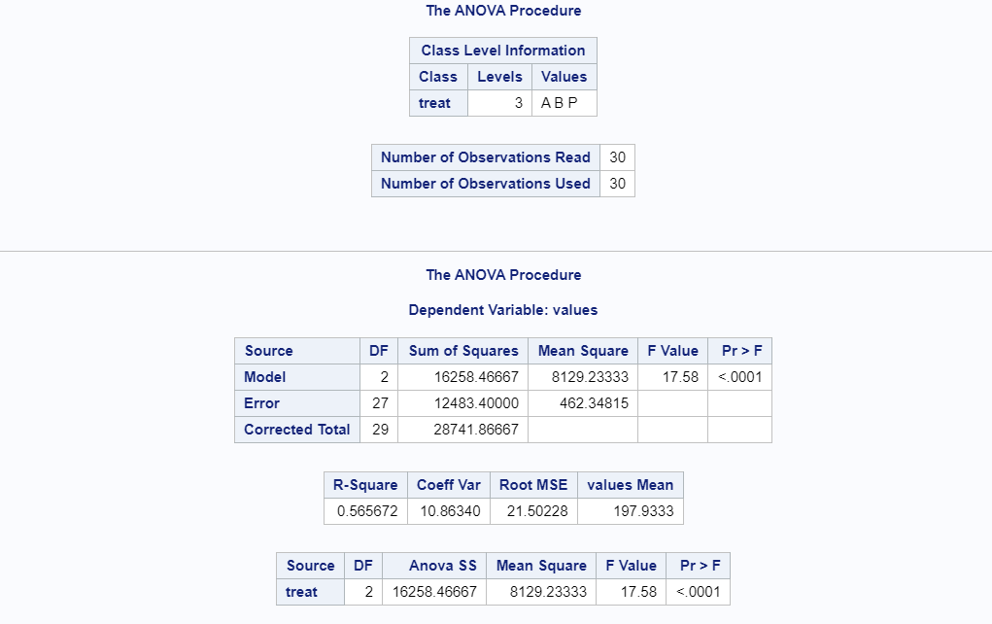 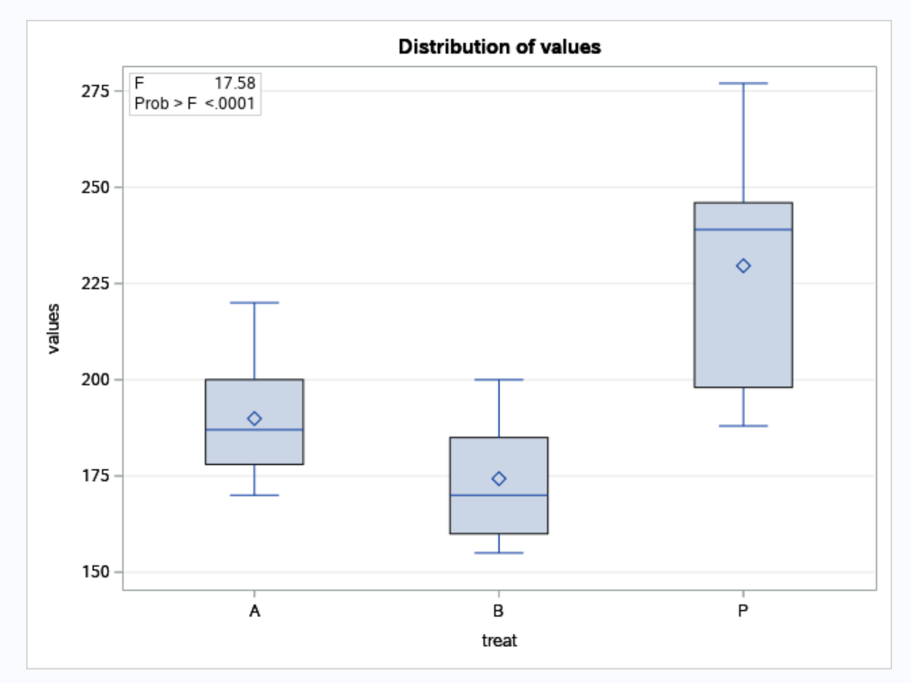 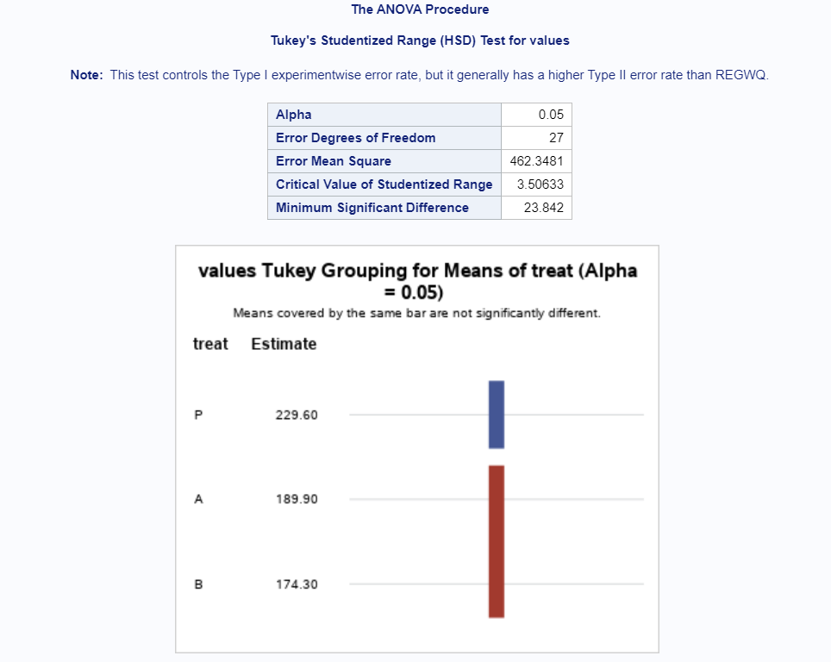

*/\* 3 \*/*

DATA df;

INPUT Age $ count brand;

DATALINES;

New 67 w

New 72 w

New 74 w

New 82 w

New 81 w

old 46 w

old 44 w

old 45 w

old 51 w

old 43 w

New 75 p

New 76 p

New 80 p

New 72 p

New 73 p

old 63 p

old 62 p

old 66 p

old 62 p

old 60 p

;

DATA df;

   DO brand = 'w','p';

      DO age = 'n','o';

         DO cell = 1 TO 5;

            INPUT count @;

            OUTPUT;

        END;

      END;

   END;

DATALINES;

67 72 74 82 81 46 44 45 51 43 75 76 80 72 73 63 62 66 62 60

;

PROC ANOVA DATA=df;

CLASS brand age;

MODEL count = brand|age;

MEANS brand|age;

RUN;

